## Summary Report

**Template**

**NAME OF COMMUNITY**



**Improving Diabetes Care Questionnaire**

Table Of Contents

Introduction 1

A. Delivery of Care 2

B. Teamwork and Continuity of Care 5

C. Resources to Support Diabetes Care 10

D. Training 15

E. Systems Supporting Care 18

F. Community Involvement and Outreach 21

G. Quality Improvement Processes 25

H. Other Areas of Diabetes Care Identified as Important for Improvement 28

I. Focus Our Efforts 29

J. Additional Thoughts or Comments 30

# Introduction

The purpose of the Improving Diabetes Care Questionnaire (IDCQ) is to determine how the healthcare clinic functions to serve patients with diabetes, and to describe areas of diabetes care that teams have identified as being important for quality improvement within their communities and organizations and possible contextual factors that may influence teams’ QI activities. To capture diverse perspectives, each member of the QI team was asked to complete the IDCQ. The REACH Program Team has created this summary report for the QI team to use in the first Workshop to help guide team discussions on identifying where the team wants to start their first PDSAs.

The questions in the IDCQ focus on the key components of health systems that can promote high quality care. Each section has space where the respondents could include additional thoughts about the topic. The Diabetes Alliance Team has summarized these comments, if any, for inclusion in the report.

# A. Delivery of Care

## Are clients with diabetes receiving appropriate care and follow-up in accordance with best practices (e.g., CPGs)?

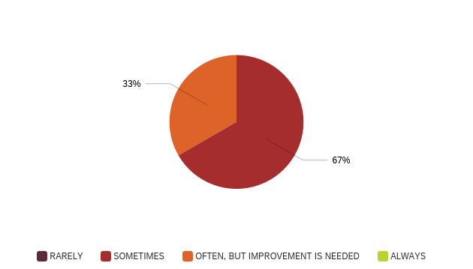

## Are available resources being effectively used to enhance regular follow-up and access to care (e.g., reminders, transportation)?

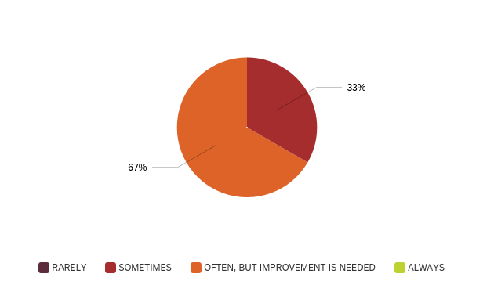

## Does routine practice include developing client care plans?

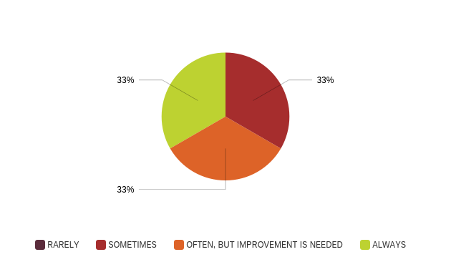

## Do healthcare professionals work with patients (as well as families where relevant) to develop self-management goals and strategies?

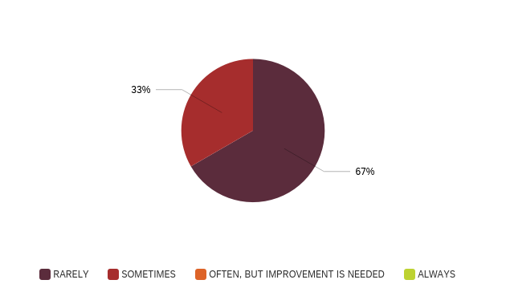

## Areas to Target for Improvement — Summary:

Lorem ipsum dolor sit amet, consectetur adipiscing elit. Mauris ex mauris, varius in dui interdum, tempus tincidunt purus. Mauris rutrum erat ac eros mollis ultrices. Nulla facilisi. Donec scelerisque dictum volutpat. Donec malesuada malesuada justo eu facilisis. In enim felis, pellentesque sed rhoncus non, porta eget dolor. Phasellus imperdiet condimentum justo, in fermentum neque accumsan eget. Donec dapibus quam metus, at convallis turpis ultricies ut. Phasellus sit amet efficitur quam. Phasellus a fringilla nisi. Nunc pulvinar a nisl vitae facilisis. Sed gravida in elit a semper. Integer molestie pulvinar est a molestie. Nunc congue cursus nunc eget auctor. Lorem ipsum dolor sit amet, consectetur adipiscing elit. Aliquam laoreet consectetur mi ut imperdiet.

Mauris at ipsum lectus. Integer eu feugiat ipsum. Nullam tincidunt non est sed mattis. Donec libero ante, bibendum a lectus in, dapibus pharetra nisi. Sed dignissim orci sit amet turpis ultrices, vel malesuada leo ullamcorper. Pellentesque eget feugiat turpis, a convallis augue. Pellentesque orci velit, hendrerit nec velit vel, sagittis lacinia turpis. Phasellus quis lorem porta, vulputate quam sed, gravida velit. Orci varius natoque penatibus et magnis dis parturient montes, nascetur ridiculus mus. Nullam bibendum non risus vitae faucibus.

# B. Teamwork and Continuity of Care

## How well is the team-based approach to diabetes care working within your health centre (e.g., clear roles, good communication)?

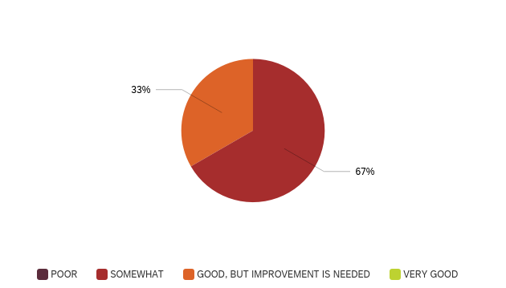

## How effective is the collaboration between specialists and generalists for providing diabetes care?

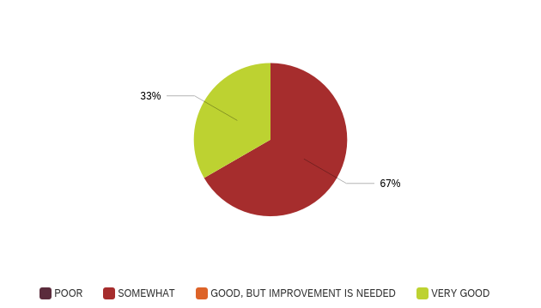

## How effective are the arrangements in place to link clients with diabetes to community health and health related resources?

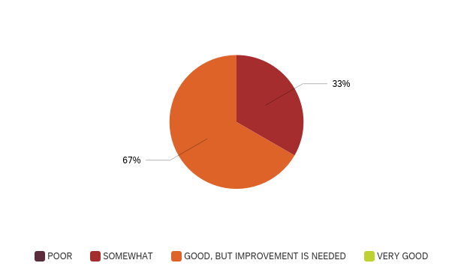

## How effective is the design and delivery of care in terms of its ability to support the continuity of care for clients with diabetes in the community (e.g., sharing of client records, case management)?

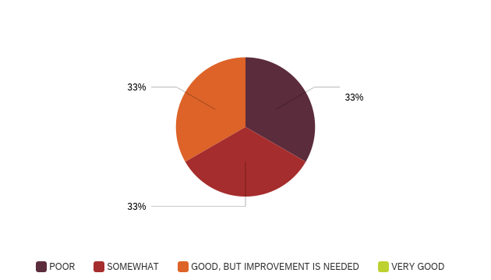

## After a client with diabetes is discharged from hospital, how effective is the communication between the hospital and your health centre?

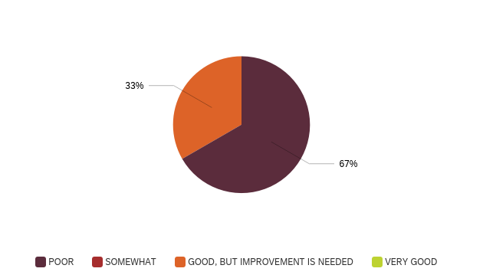

## Are joint appointments with multiple healthcare professionals offered regularly to clients with diabetes?

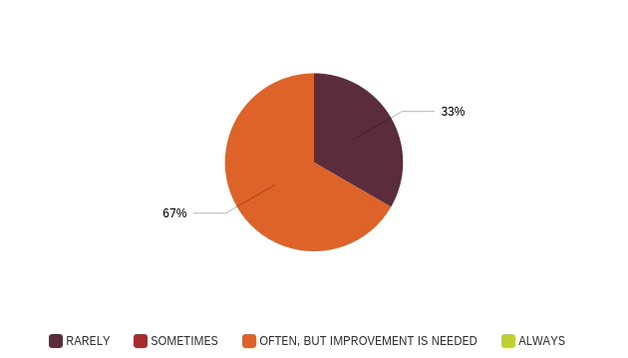

## Are clients with diabetes able to see the same healthcare professionals on a regular basis?

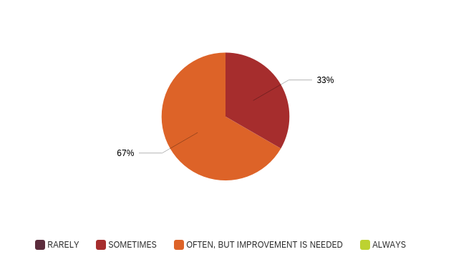

## Do you think clients feel comfortable visiting your health centre?

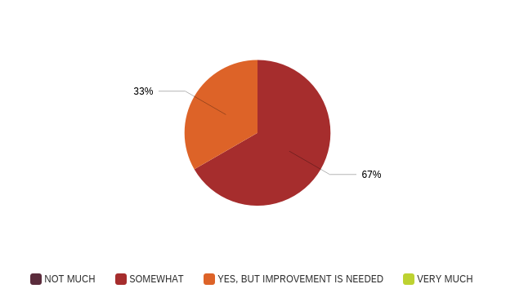

## Areas to Target for Improvement — Summary:

Lorem ipsum dolor sit amet, consectetur adipiscing elit. Mauris ex mauris, varius in dui interdum, tempus tincidunt purus. Mauris rutrum erat ac eros mollis ultrices. Nulla facilisi. Donec scelerisque dictum volutpat. Donec malesuada malesuada justo eu facilisis. In enim felis, pellentesque sed rhoncus non, porta eget dolor. Phasellus imperdiet condimentum justo, in fermentum neque accumsan eget. Donec dapibus quam metus, at convallis turpis ultricies ut. Phasellus sit amet efficitur quam. Phasellus a fringilla nisi. Nunc pulvinar a nisl vitae facilisis. Sed gravida in elit a semper. Integer molestie pulvinar est a molestie. Nunc congue cursus nunc eget auctor. Lorem ipsum dolor sit amet, consectetur adipiscing elit. Aliquam laoreet consectetur mi ut imperdiet.

Mauris at ipsum lectus. Integer eu feugiat ipsum. Nullam tincidunt non est sed mattis. Donec libero ante, bibendum a lectus in, dapibus pharetra nisi. Sed dignissim orci sit amet turpis ultrices, vel malesuada leo ullamcorper. Pellentesque eget feugiat turpis, a convallis augue. Pellentesque orci velit, hendrerit nec velit vel, sagittis lacinia turpis. Phasellus quis lorem porta, vulputate quam sed, gravida velit. Orci varius natoque penatibus et magnis dis parturient montes, nascetur ridiculus mus. Nullam bibendum non risus vitae faucibu

# C. Resources to Support Diabetes Care

## Is there an appropriate amount of healthcare professionals within your health centre who support a team-based approach to diabetes care?

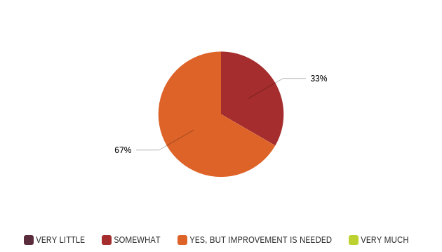

## Are there a range of specialists available for clients with diabetes outside your health centre?

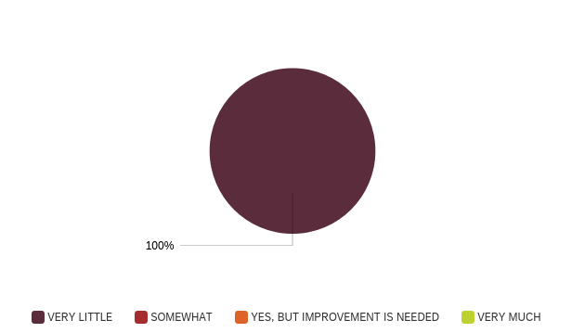

## How effective is the health centre’s strategic plan, specifically in terms of its commitment to patients with diabetes?



## How adequate is the funding that is dedicated to diabetes care?

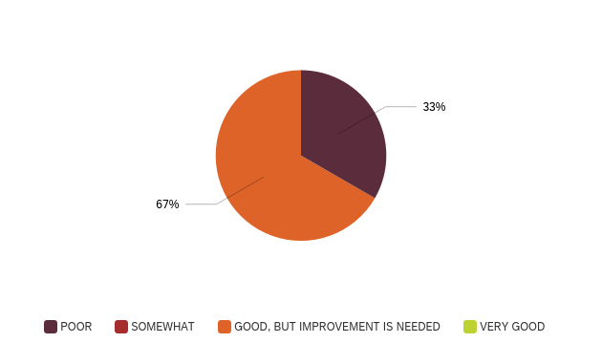

## How adequate are the supplies available for diabetes management (e.g., glucose test strips, needles, blood pressure equipment)?



## Is the physical space and layout of your healthcare organization suitable for the provision of diabetes care (e.g., enough space for staff, available exam rooms)?

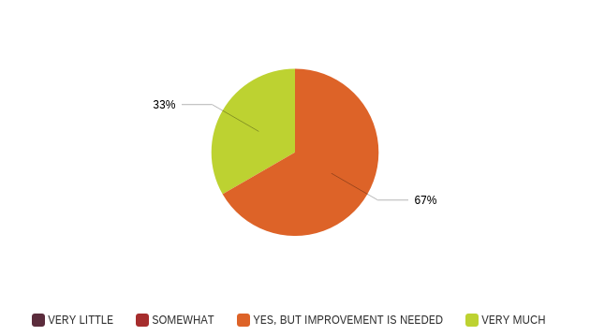

## Is there an appropriate amount of resources available to support access to care for clients with diabetes (e.g., transportation, translation services)?

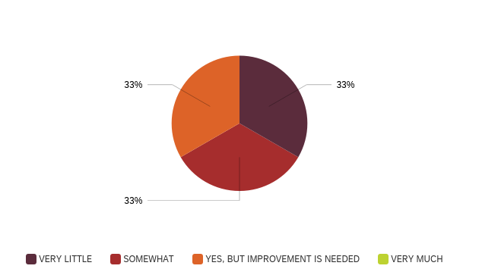

## Are there resources and tools available to support client’s diabetes management at home?

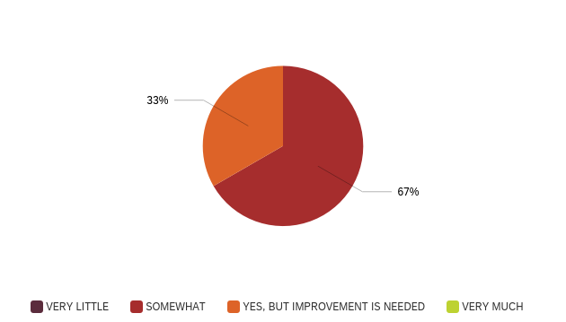

## Areas to Target for Improvement — Summary:

Lorem ipsum dolor sit amet, consectetur adipiscing elit. Mauris ex mauris, varius in dui interdum, tempus tincidunt purus. Mauris rutrum erat ac eros mollis ultrices. Nulla facilisi. Donec scelerisque dictum volutpat. Donec malesuada malesuada justo eu facilisis. In enim felis, pellentesque sed rhoncus non, porta eget dolor. Phasellus imperdiet condimentum justo, in fermentum neque accumsan eget. Donec dapibus quam metus, at convallis turpis ultricies ut. Phasellus sit amet efficitur quam. Phasellus a fringilla nisi. Nunc pulvinar a nisl vitae facilisis. Sed gravida in elit a semper. Integer molestie pulvinar est a molestie. Nunc congue cursus nunc eget auctor. Lorem ipsum dolor sit amet, consectetur adipiscing elit. Aliquam laoreet consectetur mi ut imperdiet.

Mauris at ipsum lectus. Integer eu feugiat ipsum. Nullam tincidunt non est sed mattis. Donec libero ante, bibendum a lectus in, dapibus pharetra nisi. Sed dignissim orci sit amet turpis ultrices, vel malesuada leo ullamcorper. Pellentesque eget feugiat turpis, a convallis augue. Pellentesque orci velit, hendrerit nec velit vel, sagittis lacinia turpis. Phasellus quis lorem porta, vulputate quam sed, gravida velit. Orci varius natoque penatibus et magnis dis parturient montes, nascetur ridiculus mus. Nullam bibendum non risus vitae faucibus.

# D. Training

## How adequate are training services, specifically in terms of ensuring that staff are aware of new changes in diabetes management or guidelines?



## How trained and skilled are staff to support client’s diabetes self-management?

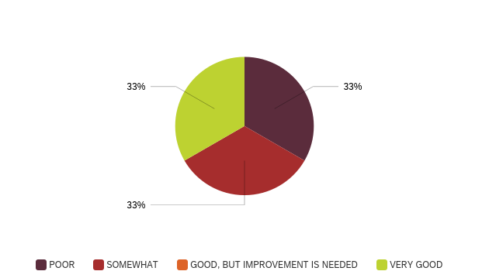

## How effective are approaches to ensure staff provide culturally relevant and appropriate care?



## Areas to Target for Improvement — Summary:

Lorem ipsum dolor sit amet, consectetur adipiscing elit. Mauris ex mauris, varius in dui interdum, tempus tincidunt purus. Mauris rutrum erat ac eros mollis ultrices. Nulla facilisi. Donec scelerisque dictum volutpat. Donec malesuada malesuada justo eu facilisis. In enim felis, pellentesque sed rhoncus non, porta eget dolor. Phasellus imperdiet condimentum justo, in fermentum neque accumsan eget. Donec dapibus quam metus, at convallis turpis ultricies ut. Phasellus sit amet efficitur quam. Phasellus a fringilla nisi. Nunc pulvinar a nisl vitae facilisis. Sed gravida in elit a semper. Integer molestie pulvinar est a molestie. Nunc congue cursus nunc eget auctor. Lorem ipsum dolor sit amet, consectetur adipiscing elit. Aliquam laoreet consectetur mi ut imperdiet.

Mauris at ipsum lectus. Integer eu feugiat ipsum. Nullam tincidunt non est sed mattis. Donec libero ante, bibendum a lectus in, dapibus pharetra nisi. Sed dignissim orci sit amet turpis ultrices, vel malesuada leo ullamcorper. Pellentesque eget feugiat turpis, a convallis augue. Pellentesque orci velit, hendrerit nec velit vel, sagittis lacinia turpis. Phasellus quis lorem porta, vulputate quam sed, gravida velit. Orci varius natoque penatibus et magnis dis parturient montes, nascetur ridiculus mus. Nullam bibendum non risus vitae faucibus.

# E. Systems Supporting Care

## To what extent do you use your appointment system to support diabetes care (e.g., follow-up, reminders)?

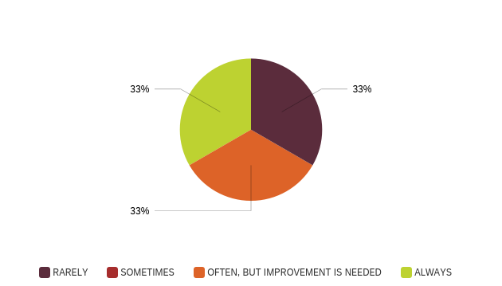

## To what extent, is a list or registry of people with diabetes in the community used as part of routine practice?

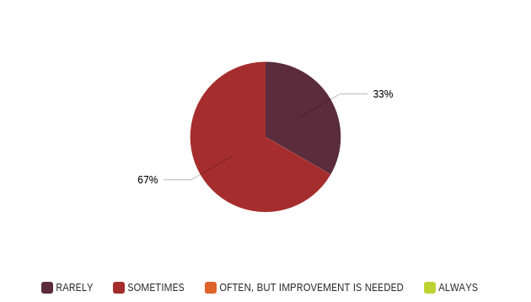

## To what extent, do healthcare professionals use client information systems for tracking and supporting diabetes care for clients?



## Areas to Target for Improvement — Summary:

Lorem ipsum dolor sit amet, consectetur adipiscing elit. Mauris ex mauris, varius in dui interdum, tempus tincidunt purus. Mauris rutrum erat ac eros mollis ultrices. Nulla facilisi. Donec scelerisque dictum volutpat. Donec malesuada malesuada justo eu facilisis. In enim felis, pellentesque sed rhoncus non, porta eget dolor. Phasellus imperdiet condimentum justo, in fermentum neque accumsan eget. Donec dapibus quam metus, at convallis turpis ultricies ut. Phasellus sit amet efficitur quam. Phasellus a fringilla nisi. Nunc pulvinar a nisl vitae facilisis. Sed gravida in elit a semper. Integer molestie pulvinar est a molestie. Nunc congue cursus nunc eget auctor. Lorem ipsum dolor sit amet, consectetur adipiscing elit. Aliquam laoreet consectetur mi ut imperdiet.

Mauris at ipsum lectus. Integer eu feugiat ipsum. Nullam tincidunt non est sed mattis. Donec libero ante, bibendum a lectus in, dapibus pharetra nisi. Sed dignissim orci sit amet turpis ultrices, vel malesuada leo ullamcorper. Pellentesque eget feugiat turpis, a convallis augue. Pellentesque orci velit, hendrerit nec velit vel, sagittis lacinia turpis. Phasellus quis lorem porta, vulputate quam sed, gravida velit. Orci varius natoque penatibus et magnis dis parturient montes, nascetur ridiculus mus. Nullam bibendum non risus vitae faucibus.

# F. Community Involvement and Outreach

## To what extent does community leadership provide input or feedback into health programs or services?



## To what extent is local Indigenous knowledge and experience incorporated into planning the approach to diabetes care services & programs?



## Are health centre staff engaged in community outreach activities (e.g., health promotion)?



## To what extent are clients asked for feedback on the quality of care they receive?



## To what extent are partnerships with community groups beneficial in connecting patients to community groups, activities, or services?



## Areas to Target for Improvement — Summary:

Lorem ipsum dolor sit amet, consectetur adipiscing elit. Mauris ex mauris, varius in dui interdum, tempus tincidunt purus. Mauris rutrum erat ac eros mollis ultrices. Nulla facilisi. Donec scelerisque dictum volutpat. Donec malesuada malesuada justo eu facilisis. In enim felis, pellentesque sed rhoncus non, porta eget dolor. Phasellus imperdiet condimentum justo, in fermentum neque accumsan eget. Donec dapibus quam metus, at convallis turpis ultricies ut. Phasellus sit amet efficitur quam. Phasellus a fringilla nisi. Nunc pulvinar a nisl vitae facilisis. Sed gravida in elit a semper. Integer molestie pulvinar est a molestie. Nunc congue cursus nunc eget auctor. Lorem ipsum dolor sit amet, consectetur adipiscing elit. Aliquam laoreet consectetur mi ut imperdiet.

Mauris at ipsum lectus. Integer eu feugiat ipsum. Nullam tincidunt non est sed mattis. Donec libero ante, bibendum a lectus in, dapibus pharetra nisi. Sed dignissim orci sit amet turpis ultrices, vel malesuada leo ullamcorper. Pellentesque eget feugiat turpis, a convallis augue. Pellentesque orci velit, hendrerit nec velit vel, sagittis lacinia turpis. Phasellus quis lorem porta, vulputate quam sed, gravida velit. Orci varius natoque penatibus et magnis dis parturient montes, nascetur ridiculus mus. Nullam bibendum non risus vitae faucibus.

# G. Quality Improvement Processes

## To what extent are quality improvement procedures or processes in place and used within the health center?

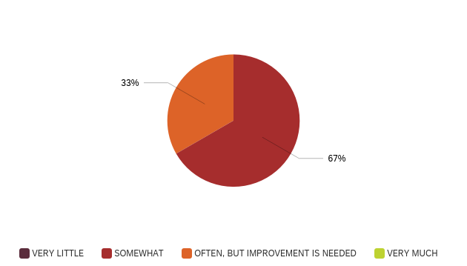

## To what extent are resources and tools (e.g., information systems) used to inform the improvement of diabetes care?

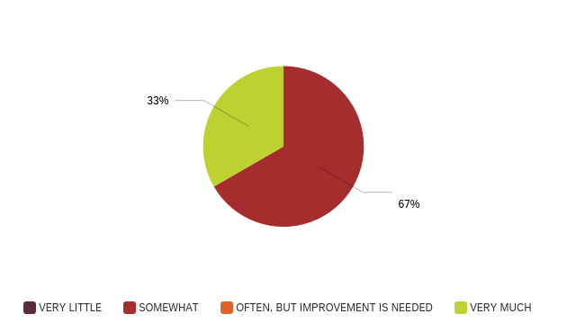

## To what extent does management/senior staff support quality improvement for diabetes care?

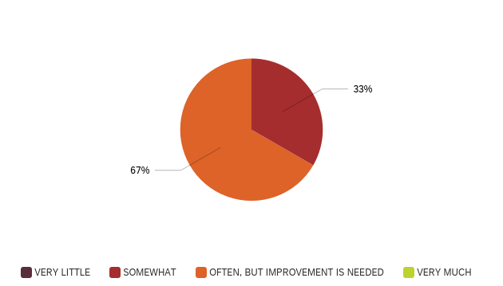

## Areas to Target for Improvement — Summary:

Lorem ipsum dolor sit amet, consectetur adipiscing elit. Mauris ex mauris, varius in dui interdum, tempus tincidunt purus. Mauris rutrum erat ac eros mollis ultrices. Nulla facilisi. Donec scelerisque dictum volutpat. Donec malesuada malesuada justo eu facilisis. In enim felis, pellentesque sed rhoncus non, porta eget dolor. Phasellus imperdiet condimentum justo, in fermentum neque accumsan eget. Donec dapibus quam metus, at convallis turpis ultricies ut. Phasellus sit amet efficitur quam. Phasellus a fringilla nisi. Nunc pulvinar a nisl vitae facilisis. Sed gravida in elit a semper. Integer molestie pulvinar est a molestie. Nunc congue cursus nunc eget auctor. Lorem ipsum dolor sit amet, consectetur adipiscing elit. Aliquam laoreet consectetur mi ut imperdiet.

Mauris at ipsum lectus. Integer eu feugiat ipsum. Nullam tincidunt non est sed mattis. Donec libero ante, bibendum a lectus in, dapibus pharetra nisi. Sed dignissim orci sit amet turpis ultrices, vel malesuada leo ullamcorper. Pellentesque eget feugiat turpis, a convallis augue. Pellentesque orci velit, hendrerit nec velit vel, sagittis lacinia turpis. Phasellus quis lorem porta, vulputate quam sed, gravida velit. Orci varius natoque penatibus et magnis dis parturient montes, nascetur ridiculus mus. Nullam bibendum non risus vitae faucibus.

# H. Other Areas of Diabetes Care Identified as Important for Improvement

## Areas to Target for Improvement — Summary:

Lorem ipsum dolor sit amet, consectetur adipiscing elit. Mauris ex mauris, varius in dui interdum, tempus tincidunt purus. Mauris rutrum erat ac eros mollis ultrices. Nulla facilisi. Donec scelerisque dictum volutpat. Donec malesuada malesuada justo eu facilisis. In enim felis, pellentesque sed rhoncus non, porta eget dolor. Phasellus imperdiet condimentum justo, in fermentum neque accumsan eget. Donec dapibus quam metus, at convallis turpis ultricies ut. Phasellus sit amet efficitur quam. Phasellus a fringilla nisi. Nunc pulvinar a nisl vitae facilisis. Sed gravida in elit a semper. Integer molestie pulvinar est a molestie. Nunc congue cursus nunc eget auctor. Lorem ipsum dolor sit amet, consectetur adipiscing elit. Aliquam laoreet consectetur mi ut imperdiet.

Mauris at ipsum lectus. Integer eu feugiat ipsum. Nullam tincidunt non est sed mattis. Donec libero ante, bibendum a lectus in, dapibus pharetra nisi. Sed dignissim orci sit amet turpis ultrices, vel malesuada leo ullamcorper. Pellentesque eget feugiat turpis, a convallis augue. Pellentesque orci velit, hendrerit nec velit vel, sagittis lacinia turpis. Phasellus quis lorem porta, vulputate quam sed, gravida velit. Orci varius natoque penatibus et magnis dis parturient montes, nascetur ridiculus mus. Nullam bibendum non risus vitae faucibus.

# I. Focus Our Efforts

**Top 4 Areas of Diabetes Care to Target for Improvement (realistically change in short time period)**

Rated #1:

* Lorem ipsum

Rated #2:

* Lorem ipsum

Rated #3:

* Lorem ipsum

Rated #4:

* Lorem ipsum

Area of Diabetes Care Most Important or in Need of Change

Lorem ipsum dolor sit amet, consectetur adipiscing elit. Mauris ex mauris, varius in dui interdum, tempus tincidunt purus. Mauris rutrum erat ac eros mollis ultrices. Nulla facilisi. Donec scelerisque dictum volutpat. Donec malesuada malesuada justo eu facilisis. In enim felis, pellentesque sed rhoncus non, porta eget dolor. Phasellus imperdiet condimentum justo, in fermentum neque accumsan eget. Donec dapibus quam metus, at convallis turpis ultricies ut. Phasellus sit amet efficitur quam. Phasellus a fringilla nisi. Nunc pulvinar a nisl vitae facilisis. Sed gravida in elit a semper. Integer molestie pulvinar est a molestie. Nunc congue cursus nunc eget auctor. Lorem ipsum dolor sit amet, consectetur adipiscing elit. Aliquam laoreet consectetur mi ut imperdiet.

Mauris at ipsum lectus. Integer eu feugiat ipsum. Nullam tincidunt non est sed mattis. Donec libero ante, bibendum a lectus in, dapibus pharetra nisi. Sed dignissim orci sit amet turpis ultrices, vel malesuada leo ullamcorper. Pellentesque eget feugiat turpis, a convallis augue. Pellentesque orci velit, hendrerit nec velit vel, sagittis lacinia turpis.

# J. Additional Thoughts or Comments

Lorem ipsum dolor sit amet, consectetur adipiscing elit. Mauris ex mauris, varius in dui interdum, tempus tincidunt purus. Mauris rutrum erat ac eros mollis ultrices. Nulla facilisi. Donec scelerisque dictum volutpat. Donec malesuada malesuada justo eu facilisis. In enim felis, pellentesque sed rhoncus non, porta eget dolor. Phasellus imperdiet condimentum justo, in fermentum neque accumsan eget. Donec dapibus quam metus, at convallis turpis ultricies ut. Phasellus sit amet efficitur quam. Phasellus a fringilla nisi. Nunc pulvinar a nisl vitae facilisis. Sed gravida in elit a semper. Integer molestie pulvinar est a molestie. Nunc congue cursus nunc eget auctor. Lorem ipsum dolor sit amet, consectetur adipiscing elit. Aliquam laoreet consectetur mi ut imperdiet.

Mauris at ipsum lectus. Integer eu feugiat ipsum. Nullam tincidunt non est sed mattis. Donec libero ante, bibendum a lectus in, dapibus pharetra nisi. Sed dignissim orci sit amet turpis ultrices, vel malesuada leo ullamcorper. Pellentesque eget feugiat turpis, a convallis augue. Pellentesque orci velit, hendrerit nec velit vel, sagittis lacinia turpis. Phasellus quis lorem porta, vulputate quam sed, gravida velit. Orci varius natoque penatibus et magnis dis parturient montes, nascetur ridiculus mus. Nullam bibendum non risus vitae faucibus.